Chebsey Parish Council
Sue Stokes
357 Stone Road Stafford ST16 1LD
Tel: 07943920070 Email: s.stokes@btinternet.com
Minutes of the meeting of Chebsey Parish Council held on
Monday 5th December 2022 7pm
In Chebsey Parish Hall
Cllr’s Present: Cllr M Ainsworth-Hickman (Chair) Cllr R Hopley (Vice Chair) Cllr B Jones Cllr J Lawson Cllr S Edge Cllr D Foster-Birks
In Attendance: S Stokes (Clerk)
Members of the public: None
22/178 | Welcome and Public Participation. (Please refer to the Chebsey Parish Council Public Participation Policy which can be found on www.chebseyparishcouncil.org.uk )  The Chair welcomed everyone to the meeting.
22/179 | Apologies.  Cllr B Samra Cllr J Pert (SBC SCC) Cllr P Jones (SBC)
22/180 | Declarations of interest, to consider written requests from Cllr’s for the Council to grant a dispensation (S33 of the Localism Act 2011.)  Cllr S Edge declared an interest in Item 22/189 Meecebrook.
22/181 | Minutes and Matters arising from the Parish Council Meetings held on 7th November 2022 and the Extra Ordinary meeting held on 1st December 2022.  Item 22/162 Mr Davis & Mr Green have responded to the clerks email. A date for the unveiling of the commemorative bench will be decided at the January meeting.  Item 22/176 The Meecebrook flyer has been printed and is ready for distribution. Cllr B. Jones and Cllr Ainsworth-Hickman have produced a document for the Preferred Options consultation ready for discussion.  The minutes of the meetings held on 7th November 2022 and 1st December 2022 were approved as a true record of the meetings by everyone present. The Chair signed the minutes.
22/182 | Finance and Budget. To approve December expenditure.  Cheque no 965 covered the Meecebrook and afternoon tea flyers( Total for flyers £73 less than the £81 quoted) and the Chebsey Hall Hire (payable to S. Stokes) S. Stokes made payments via BACS £133.00  Nat West Statement to 25th November 2022 £7673.45  Cheque no 966 WEL Medical Norton Bridge Defib battery (£35.99 VAT to be reclaimed) (un presented) £215.94  For Approval  Cheque no 967 D M Payroll Services Admin for payroll Oct 22 - March 23 £40.00  Clerks salary for Dec (increase and arrears yet to be calculated) plus reimbursement for Epson printer ink (£224.20 + £7.75 = £231.95) Cheque no 968 £231.95  The balance of the Nat West Account on the cash sheet stands at £7185.56  Payment for 2nd Meecebrook flyer to be agreed. (Invoice not yet received.)  Recreation area inspection delayed awaiting invoice (£90.00)  No invoice received for clerks training in October .(SPCA notified) (£30.00)  All payments above approved by everyone present.  To discuss precept for 23/24. Budget review.  Our tax base (no. Of qualifying properties after allowing for discounts such as single occupation, social need etc), has fallen by 4.72 units last year. As such we start by being £119 worse off if everything had stayed the same. (Precept of £25.27)  The 1.5% increase shown on the spreadsheet is effectively the extra that each of the qualifying properties would pay on average if we keep the total amount of precept the same as last year. (The charge per house of depending on the amount of £25.65 for band D properties will of course be higher for band E-G properties and lower for band A-C properties).  The following example % changes will raise the following precept.  - Keep the precept (band D equivalent) same as this year - £25.27 is a decrease of 1.5% and precept will be £6330 (a decrease of £119)  - Keep the precept at the 2022/23 level at £6,444 will be an increase (to band D equivalent) to 25.75 or +1.9%  - Examples for comparison - Increase precept by £100 more than this year (£6,544) band D charge £26.15 or increase of 3.5%` - increase precept by £200 more than this year (£6,644) band D charge £26.55 or increase of 5.5%  After a lengthy discussion the Cllr’s present unanimously agreed that the precept should be increased by 3.5%. This would give an increase of £100 for the year 2023/24 .The clerk will notify Mr J Bellingham at Stafford Borough Council. Action clerk.  Friends of Norton Bridge have agreed to pay half of the cost of the new battery for the Norton Bridge Defibrillator .The clerk will send Friends of Norton Bridge an invoice. Action clerk  Budget review.  Budget & spend update to End Oct 2022.  Cllr B Jones has produced the latest analysis of spend vs 2022/23 Budget.  It will be seen that after 7 months of the year CPC spending is tracking below budget and well below the outcome for the previous year, where total spending exceeded income by £1,865.  As CPC has not incurred any exceptional project costs, so far this year, it is highly likely that income will be greater than expenditure by perhaps £1,000 or even more, thus increasing the CPC cash balance to circa £6,700 at 31 March 2023 (£5,755 at 31st March 2022).  Careful control of costs for the remaining months of the current year is, as ever, required as inflation will inevitably have some impact. Overall however costs are being well controlled.  First Draft Budget 2023/24  A "first draft Budget" has been added to the monthly spend analysis.  The draft assumes the following:  1. The Precept for the new year will be the same amount as the current year (effectively a 1.9% increase to residents to offset the fall in the "tax base" as advised by SBC).  2. The regular costs of amenity visits are based on indications of costs per hour increases by SBC for 7 visits per annum.  3. Other costs are estimates for discussion and are based on past record and some simple "guesses"  4. No assumptions are made regarding special projects or election costs.  The budget was discussed Cllr B Jones asked if anyone knew of any large expenses that may affect the budget for next year. The clerk mentioned the possibility of doing the Cilca course which would cost about £700.
22/183 | Technical & Infrastructure Parish Policies. (To include update on the website and Face book page.)  The clerk has sent out the website to the Cllr’s for approval. Once approved the clerk will contact SCC website providers to get the site live.  The Facebook page is up and running and currently has 7 followers.  Chebsey Parish Councils complaints policy and social media policy were discussed. The Cllr’s approved both policies. The Policies have been adopted and will be displayed on the website. Action clerk.  Cllr B Samra created a diagram showing the availability of 5G in the various locations - no one in the Chebsey parish has access to 5G apart from maybe 1.5 houses in Lakesedge in Cold Norton  4G is very good in most areas apart from Swynnerton and Chebsey!  Cllr B Samara  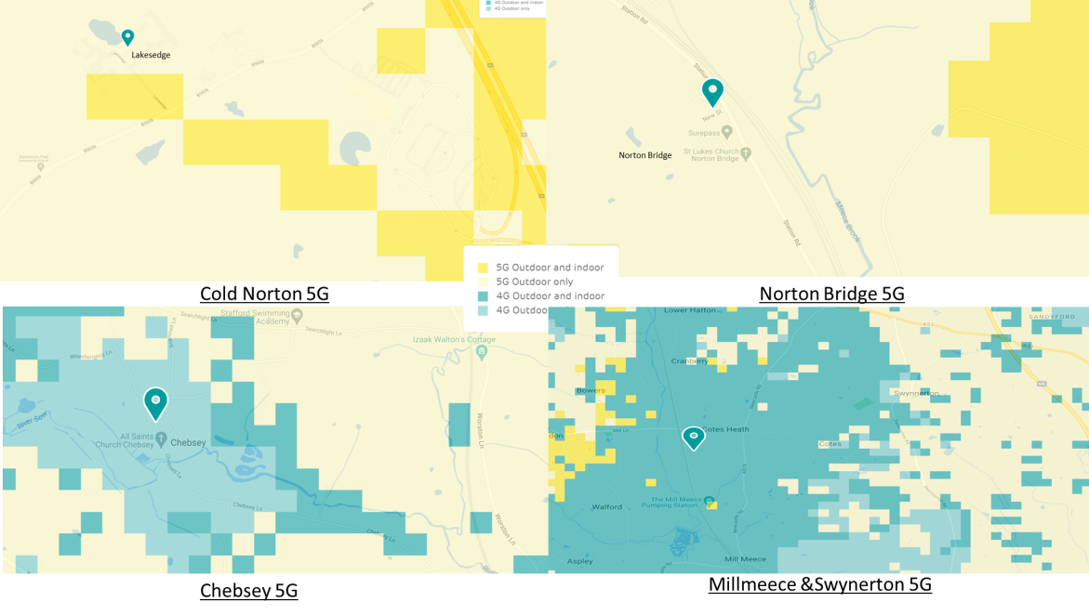
22/184 | Leisure facilities, Recreation Area & Open Spaces  The annual recreation area inspection has not yet been completed due to a shortage of inspectors because of sickness. The inspection will be completed as soon as possible.  Friends of Norton Bridge are still looking into the plot of land. They are hoping to have a community tidy up of the recreation area in the Spring. The bus route questionnaire is ready to be distributed. It will be sent out after Christmas.
22/185 | Events & Social Funding.  Update on Events and Social Fund Raising – December 2022  Thursday 24th November – Warm Spaces starts at Shallowford House  Monday 28th November – Joint Parish Council Meeting with SBC, Planning re Meecebrook  Tuesday 29th November – Eccleshall Parish Council Planning Meeting  Saturday 10th December – Christmas Afternoon Tea, 12.00-4.30pm, Chebsey Parish Hall  Monday 12th December – Meecebrook Consultation Closes  Monday 12th December – HS2 Meeting with Joe Wilson, 7-8pm  Monday 9th January – Parish Council Meeting  Wednesday 25th January – Stone Area Parish Liasion Meeting  Saturday 4th March – Civic Amenity Visit  Monday 13th March – HS2 Meeting  Saturday 20th May – Civic Amenity Visit  Saturday 17th June – Civic Amenity Visit Monday  12th July – HS2 Meeting  Monday 11th September – HS2 Meeting  Saturday 23rd September – Civic Amenity Visit  Saturday 28th October –Civic Amenity Visit  Saturday 25th November – Civic Amenity visit  The Warm Spaces Project started 23rd November and each centre has now opened up to the community.  I have visited each venue for their first session and the feedback has been very encouraging, albeit we need to keep promoting the project. At Great Bridgeford three elderly ladies were almost in tears saying ‘that normally they eat at home on their own and to be able to share a meal with friends in a warm environment is just amazing’  At Ranton, one elderly couple said that they’d lived in the village 52 years and they met people who live in the village for the first time. The Co-Coordinator even said she’d ‘met a lady from down her street whom she’d never met before’. Social Isolation in rural communities is a very real issue. The one clear feedback is that is apparent throughout them all is the social isolation of individuals in the community.  Cllr Ainsworth-Hickman said a huge thank you to Shallowford House for their help with the project.  Christmas Afternoon Tea At present we have 126 people booked in with a good number of children to see Santa. Getting volunteers is proving more difficult this year as is help with refreshments. Unfortunately we have had to source a new Santa due to health issues with our old Santa. DBS checks have been completed now. We have to buy a new Santa outfit as the previous one was purchased by the ‘old’ Santa and he would like to keep it.  Eccleshall first responders will be arranging for CPR training for the parish.
22/186 | Highway and Footpath Matters.  The Chair asked that we contact Stafford Borough Council to arrange for road sweepers for Parsons Bank and Scamnel Lane. The Chair had received a phone call regarding the access to the public footpath by the chicken farm. The Chair advised the caller to contact Seighford Parish Council.
22/187 | Large Infrastructure, Housing & Rail (To include HS2. Any updates and funding).  It was announced at the Government's Financial Statement on 17th November that the construction of HS2a, from Birmingham to Manchester will go ahead and escape the current cost cutting exercise by government.  The plan to build the IMRB between Yarnfield and Cold Norton remains intact therefore. A number of MP's, including Sir Bill Cash, have voiced their views that HS2 is an expense that should be reconsidered.  The SRCG continues its opposition to the siting of the IMRB.  Members of CPC and Yarnfield Parish Council have a scheduled meeting with Mr Joe Wilson of HS2 in December where questions about the impact of the build on Cold Norton will be posed. A report on the meeting will be made for the January meeting.  Bob Jones
22/188 | Correspondence.  Email regarding the dates for Civic Amenity visits for 2023  The dates for the Civic Amenities visits have been set for next year  Email re Land in Chebsey. No land has been identified as available at the moment. The Cllr’s will make some enquiries.  Email re speed device from Swynerton P.C  The Cllr’s discussed the email and agreed the cost of the equipment and installation charges were not feasible. The clerk will let Swynerton P.C know. Action clerk.
22/189 | Planning Updates. (To include Meecebrook, The Lawful Development Certificate for Old Mill Farmhouse Chebsey)  No Validations since the last meeting. The only decision is for Old Mill Farm house. The Lawful Development Certificate has been allowed for this property. No documents are showing on the planning portal. The Cllr’s agreed to request sight of the documents under the Freedom of Information Act. The clerk will write to Stafford Borough Council and request the documents. Action clerk.  Cllr S Edge left the meeting at 20.12.  Meecebrook  The Chair gave the Cllr’s the Meecebrook flyers for urgent distribution.  Cllr B Jones will cover Cold Norton, Cllr J Lawson Chebsey, C. Kinnersley Lower Heamies, Cllr M Ainsworth-Hickman Hilcote, Shallowford, Scamnel, top end of Chebsey and outline Cold Norton, Cllr D Foster-Birks Norton Bridge.  The Chair thanked Cllr B Jones for all his efforts in producing the Preferred Options response document. The Cllr’s listened to the audio version of the document. The clerk will send the document out to the Cllr’s for final approval before sending it to Stafford Borough Council. The clerk will put the response on the website, with a link to the Facebook page. Action Clerk
22/190 | Items for next Parish Council Meeting.
22/191 | Date of next meeting. The next meeting will be held on 9th January 2023 in Chebsey Parish Hall. With no further business the Chair thanked everyone for their attendance and closed the meeting at 20.50
Sue Stokes Clerk to Chebsey Parish Council 7th December 2022

Signed.........................................................................Chair....................................................Dated

